TECHNICAL SPECIFICATION

Project Name | Alfresco Feeds Integration with Google Search Appliance

TECHNICAL SPECIFICATION 1
2 Supporting Documentation 2
3 Introduction 3
4 Requirements 3
5 Technical Specification and Design 4
6 Technical Requirements 9

1 Revision History
Version | Author | Date
0.1 – initial version | D Rahman | 29 October 2010

Supporting Documentation

Document | Date
Feeds Protocol Developer's Guide
http://code.google.com/apis/searchappliance/documentation/62/feedsguide.html
Google Search Appliance Administrative API Developer's Guide: Java
http://code.google.com/apis/searchappliance/documentation/60/gdata/acapi_java.html#DocumentStatusValues
Interface DictionaryService
http://dev.alfresco.com/resource/docs/java/repository/org/alfresco/service/cmr/dictionary/DictionaryService.html
Custom Actions
http://wiki.alfresco.com/wiki/Custom_Actions
Node Service API Design
http://wiki.alfresco.com/wiki/Node_Service_API_Design
Alfresco Developer: Developing Custom Actions
http://ecmarchitect.com/images/articles/alfresco-behavior/behavior-article.pdf
Scheduled Actions
http://wiki.alfresco.com/wiki/Scheduled_Actions
Adding jobs to Scheduler - schedulerFactory bean
http://forums.alfresco.com/en/viewtopic.php?t=1295

Introduction

Documents in Aidoc Alfresco content repository are crawled and indexed using the crawling facility of the Google Search Appliance. Aidoc document urls are exposed by means of a crawl webscript in Aidoc which allows the GSA to replicate the Aidoc folder structure; Year/ClassCode/Document Number under which documents are indexed.
Currently the GSA is set to continuous crawl the Aidoc document repository on a daily basis at specified times outside the scheduled backup time.
However allowing the GSA to continuously crawl documents has the following drawbacks:
- Unnecessary load on the Aidoc server - the frequency of documents in Aidoc being add, modified or deleted is minimal and does not require a continuous crawl process running constantly.
- When there is downtime on the Aidoc server, the GSA crawler receives at HTTP Response code 404 – “Document not found" and assumes the document has been removed from the Aidoc repository. Therefore it attempts to remove the document from its index.
- GSA crawler is a time consuming process and often requires approximately 3-4 days to crawl the whole Aidoc Amnesty International document collection.

Requirements

The proposed change to Aidoc’s integration with GSA is to use an asynchronous XML feed that is automatically triggered upon a change in Aidoc. This will use the Feed’s facility provided by the GSA. This will allow for the GSA continuous crawler to be switched off.
The use of feeds will have the following advantages:
- Documents that can be crawled but are best recrawled at different times than those set by the automatic crawl scheduler that runs on the search appliance.
- Documents that can be crawled but there are no links on your web site that allow the crawler to discover them during a new crawl.
- Documents that can be crawled but are much more quickly uploaded using feeds, due to web server or network problems.

Technical Specification and Design

The first step is to implement an action that includes logic to generate an XML feed with the properties of an Aidoc document node and send a multipart HTTP POST to GSA. Alfresco content repository has a mechanism to trigger actions, this is called behaviours. The behaviour can bound to a Policy which specifies the Alfresco event that will trigger the action to which the behaviour is attached to.
Then the second stage is to collect the response from the GSA and verify that the feed has been successfully sent and indexed/removed in the GSA. The result of the response will be recorded as a new property added to the Asset node in Aidoc.
As there is a time lag between the GSA accepting the HTTP POST and completing the Indexing of a document, a third stage is required. This would be to implement another action that uses the Alfresco task scheduler to search the repository and verify the document has been successfully Indexed in the GSA. If it fails, this action will attempt to resend the feed again.
In summary here is the two phase process for sending a feed and verifying index: 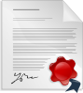
1.Behavour Policy is triggered when repository is modified.
2. Action to generate XML document and HTTP Multipart POST to GSA feeder port.
3. GSA HTTP response sent back.
4.Asset node feed property updated.
GSA Adds feed to the crawl queue instantly and adds it to the index (usually 30mins depending on load)
6.GSA responds with results of the indexed feed.
7.If feed is not found in index resend feed. Goto step(2).
5.Action run by scheduler to verify feeds using GSA Admin API

  - Behaviour Policy Triggers

The following user scenario changes to the Aidoc repository will trigger the Feeds actions:
- Adding new documents.
- Modifiying documents or document node properties.
- Deleting documents.
- Modifying the Asset node’s security class.

The following Alfresco behaviour policies will be implemented to listen out for the above events and return the NodeRef of the current document node.
Interface | Method | Description
org.alfresco.repo.node.  NodeServicePolicies | OnUpdatePropertiesPolicy | Triggers when document is added/modified/node properties modified.
org.alfresco.repo.node.  NodeServicePolicies | BeforeDeleteNodePolicy | Triggers before document node is deleted so the properties of the deleted document can be captured i.e in the scenario of security class modified.
org.alfresco.repo.node.  NodeServicePolicies | OnDeleteNodePolicy | Tirggers after the document node is deleted.

  - XML Feed Action

The input will be the NodeRef of the current document that is being modified which is returned from the behaviour policies. This action generally performs the following operation:

- The Asset properties are retrieved and marshalled using JAXB into XML format defined by the GSA DTD (See Appendix).
- XML Feed is sent in a Multipart HTTP POST to: http://<APPLIANCE-HOSTNAME>:19900/xmlfeed The HTTP POST is encoded using enctype="multipart/form-data".
- GSA response with a HTTP Response code, typically like below. The success message indicates that the feedergate process has received the XML file successfully. It does not mean that the content will be added to the index, as this is handled asynchronously by a separate process known as the "feeder".
HTTP/1.0 200 OK
Content-Type: text/plain
Date: Thu, 30 Apr 2009 23:16:10 GMT
Server: feedergate_1.0
Connection: Close
Content-Length: 7
Success

- The GSA HTTP response is recorded as a human readable message in Asset properties called “Feed Published” in Alfresco.
- URLs are passed to the GSA server that maintains Crawl Diagnostics in the Admin Console get added within 15 minutes if GSA system is not busy. The feeder also passes the URLs and their contents to the indexing process. The URLs will appear in your search results within 30 minutes if your system is not busy. Due to this internal GSA process a second phase is required to verify the feed is successfully indexed in the GSA. This is described later. For now the feed published property is set into a “Pending” state.

The operations in the action will vary according to each of the user scenarios. Outlined below is the pseudo code implementation for the following user scenarios:

    - Adding new documents

- Loop up to Asset level node from document level node.
- Verify Asset node publish date is set and in the past.
- Fetch all document renditions from the Asset.
- For each rendition marshall a GSA record object in XML using JAXB.
- Add the GSA header and group object to generate the XML conforming the GSA DTD.
- Send this XML add feed to the GSA http://<APPLIANCE-HOSTNAME>:19900/xmlfeed as Mulitpart HTTP POST.
- Get the Backlogcount from the GSA using HTTP GET request to http://SearchApplianceHostname:19900/getbacklogcount
- If response is HttpStatus.SC_OK – 200 set Feed Published to “Accepted”. If backlogcount is incremented set Feed Published to “Pending”.
- Else set Feed Published to “Failed”, assuming GSA connectivity or downtime.

Example of an add XML Feed:
<?xml version="1.0" encoding="UTF-8" standalone="no"?>
<!DOCTYPE gsafeed PUBLIC "-//Google//DTD GSA Feeds//EN" "">
<gsafeed>
<header>
<datasource>ai_alfresco</datasource>
<feedtype>incremental</feedtype>
</header>
<group>
<record lock="false" action="add" last-modified="Thu, 18 Nov 2010 15:18:11 GMT" mimetype="text/html" url="https://192.168.1.137/service/library/index/2009/AMR51/001/en" displayurl="https://192.168.1.137/service/library/index/2009/AMR51/001/en">
<metadata>
<meta content="USA: Legal concern / Unfair trial: Omar Ahmed Khadr (m)" name="AI-title"/>
<meta content="en" name="AI-language"/>
<meta content="AMR 51/001/2009" name="AI-index"/>
<meta content="AMR" name="AI-class"/>
<meta content="51" name="AI-subclass"/>
<meta content="001" name="AI-document-no"/>
<meta content="2009" name="AI-document-year"/>
<meta content="Public" name="AI-security-class"/>
<meta content="2009-01-07 00:00:00" name="AI-published"/>
<meta content="Published" name="AI-publication-status"/>
<meta content="UrgentAction" name="AI-type"/>
<meta content="2010-11-18 15:18:11" name="AI-last-modified"/>
<meta content="2009-01-07 17:00:37" name="AI-created"/>
</metadata>
<content>&lt;html&gt;&lt;title&gt;USA: Legal concern / Unfair trial: Omar Ahmed Khadr (m)&lt;/title&gt;&lt;body&gt;Omar Khadr is facing unfair trial by military commission in Guantanamo Bay for crimes he is alleged to have committed when he was 15 years old. The trial is due to begin on 26 January 2009. Amnesty International has welcomed President-elect Barack Obama's stated commitment to closing the Guantanamo detention facility but is concerned that he has made no announcements about stopping military commission proceedings.&lt;/body&gt;&lt;/html&gt;</content>
</record>
</group>
</gsafeed>

    - Modifiying documents or document node properties

Same as Adding New Documents.

    - Deleting documents

- Loop up to Asset level node from document level node.
- Fetch Asset node properties to compose URL to delete from GSA.
- Given the language parameter, get the selected rendition and marshall a GSA record object in XML using JAXB.
- Add the GSA header and group object to generate the XML conforming the GSA DTD.
- Send this XML delete feed to the GSA http://<APPLIANCE-HOSTNAME>:19900/xmlfeed as Mulitpart HTTP POST.
- Get the Backlogcount from the GSA using HTTP GET request to http://SearchApplianceHostname:19900/getbacklogcount
- If response is HttpStatus.SC_OK – 200 set Feed Published to “Accepted”. If backlogcount is incremented set Feed Published to “Pending Removal”.
- Else set Feed Published to “Failed”, assuming GSA connectivity or downtime.

Example of a XML delete Feed:

<?xml version="1.0" encoding="UTF-8" standalone="no"?>
<!DOCTYPE gsafeed PUBLIC "-//Google//DTD GSA Feeds//EN" "">
<gsafeed>
<header>
<datasource>ai_alfresco</datasource>
<feedtype>incremental</feedtype>
</header>
<group>
<record lock="false" action="delete" mimetype="text/html" url="https://192.168.1.137/service/library/index/2009/AMR51/001/en" displayurl="https://192.168.1.137/service/library/index/2009/AMR51/001/en"/>
<record lock="false" action="delete" mimetype="text/html" url="https://192.168.1.137/service/library/index/2009/AMR51/001/es" displayurl="https://192.168.1.137/service/library/index/2009/AMR51/001/es"/>
<record lock="false" action="delete" mimetype="text/html" url="https://192.168.1.137/service/library/index/2009/AMR51/001/fr" displayurl="https://192.168.1.137/service/library/index/2009/AMR51/001/fr"/>
</group>
</gsafeed>

    - Modifying the Asset node’s security class

- Loop up to Asset level node from document level node.
- If the Asset Security Class property has been changed then –
  - If the Security class is set to Public, send a delete feed with all renditions with “restricted” in the URL string i.e https://192.168.1.137/service/library/restricted/2009/AMR51/001/en
  - Send an Add Feed with the public URLs for each rendition. i.e https://192.168.1.137/service/library/index/2009/AMR51/001/en
- If the Asset Security Class property has been changed then –
  - If the Security class is set to Internal, send a delete feed with all renditions from the public collection i.e https://192.168.1.137/service/library/index/2009/AMR51/001/en
  - Send an Add Feed with the restricted URLs for each rendition. i.e https://192.168.1.137/service/library/restricted/2009/AMR51/001/en
- This will index Public documents with the ai_public collection and Internal with the ai_restricted collections setup in the GSA.

  - Verify Feed Action

This is the second phase of the Feed Action. After approximately 30mins the feed is expected to be indexed in the GSA. The next stage is to use the GSA Admin API to verify feed URLs indexed in the GSA and set the Asset’s Feed published property to its final state.

This operation is executed as a batch job when the Aidoc system is idle and is trigger by the Alfresco scheduler.

This process involves iterating through all the Asset nodes and looking at the “Feed Published” property and updating it from “Pending” state to either Completed or Failed state. If feed has failed then attempt to resend. Here are the steps for this operation:

- Start at the root node of the Aidoc folder structure i.e Index Documents and iterate through all the Asset node sequentially.
- If Feed Published is “Pending” :
  - If all document renditions URLS are successfully set Feed Published to “Completed”
  - Else set Feed Published to “Failed_in_Error”
  - If no renditions then this means all documents have been removed from Asset. Set Feed Published to “Removed”.
- Else If Feed Published is “Pending Removal” then send an Add Feed for the remainder renditions to GSA. This will put Published back into “Pending” state.
- If Feed Published is “Completed” or “Unknown” or “Removed” – do nothing.
- If Feed Published is “Failed” or “Failed_in_error” then resend Feeds again to sychronise Aidoc Asset with GSA.

  - Feed Published Status
Feed Published Status | What is means
Unknown | Initial state
Accepted | HTTP Response code 200 received from GSA
Failed | No HTTP Response from GSA. GSA Failure or downtime.
Pending | Process index GSA Backlogcount incremented for Add feed.
Pending Removal | Process index GSA Backlogcount incremented for Delete feed.
Completed | Verified and document indexed in GSA successfully
Removed | All renditions removed.
Failed_in_error | GSA’s internal feeder process failure. Retries to send Feed again.

Technical Requirements

Here are the changes made to the amp-aicore code base.
  - Application Code Changes
    - Java Files
Interface | Java Class | Description
org.amnesty.aidoc | aicoreConfig | Contain GSA feed properties initialised from aicore.properties file.
org.amnesty.aidoc | aicorePolicyAction | Interface for the methods required for feed and reporting action implementations.
org.amnesty.aidoc | AiNodeServicePolicies | Control what Actions either Reporting or Feed upon triggering of Alfresco behaviour policies. This is configured in bootstrap-context.xml for the spring bean dependency injection.
org.amnesty.aidoc | Constants.java | Addition of Property: Feed Publishable
org.amnesty.aidoc.feeder | ContentFeedBuilder | Marshalls Aidoc Asset object into GSA XML feed format conforming to GSA Feed DTD.
org.amnesty.aidoc.feeder | GsaFeedergateClient | Performs Multipart HTTP POST to GSA feeder port.
org.amnesty.aidoc.feeder | GsaFeedImpl | JAXB object implementation model from GSA Feed DTD.  Data Objects Modelled:  Header – contains GSA feed collection and feed type.  Group – Collection of Records  Record – Rendition URLS and properties, includes collection of Meta.  Meta – Include metadata
org.amnesty.aidoc.feeder | Indexing | Implementation of aicorePolicyAction’s methods for the Feeds. Perform the XML Feed Action which retrieves all properties from Asset node to include in the GSA XML feed.
org.amnesty.aidoc.feeder | IndexingFeedActionExecutor | Action to search all Asset nodes and verify all feeds have been indexed successfully in GSA as part of an asynchronous process.
org.amnesty.aidoc.feeder | IndexFeeder | Add and Delete Feed methods which takes Asset node ref as parameter. Iterates renditions and generate a Record to include in the GSA feed.
org.amnesty.aidoc.feeder | IndexFeederState | Determines Feed Published property’s String message state. Contains backlogcount method.
org.amnesty.aidoc.feeder (junit test) | ContentFeedBuilderTest | Tests XML Feed content.
org.amnesty.aidoc.feeder (junit test) | GsaFeedergateClient | Test sending HTTP POST to GSA.

  - Spring XML Context Configurations Files
Location | Context File | Description
Src/main/resources/ alfresco/extension | Indexfeeder-context.xml | Configuration of IndexFeedActionExecuter to run as an Action
Src/main/resources/ alfresco/extension | Indexingfeeder.properties | Text string for the Action name appearing in the drop down down list when Running Action in Alfresco console.
Src/main/config/ context | Bootstrap-context.xml | Declare IndexingAction bean. This is where you can enable/disable Feeder and Reporting Actions.
Src/main/config/ context | Service-context.xml | Configuration of IndexFeedActionExecuter to run as a scheduled job.
Src/main/config/ context | Web-scripts-application-context.xml | Declare Asset Feed Webscript – resends all GSA to restore GSA.

    - Bootstrap-content.xml – How to turn on/off Feeding functionality

The Indexing Feeders Actions and the relevant dependency injection beans are declared here. The Enabled property of the IndexingAction and ReportingAction take a value of “true” or “false” which turns control the Feeds and Reporting feature.
Bean | Java Class | Description
ReportingAction | org.amnesty.aidoc. report.Reporting | Generates Reports in the form of XML feeds for Crystal Reports Sybase database reporting.
IndexingAction | org.amnesty.aidoc. feeder.Indexing | Main class to start the Feeding process once triggered by behaviour policies.
IndexingFeeder | org.amnesty.aidoc. feeder.IndexingFeeder | Add and Delete Feed methods.
IndexingFeedState | org.amnesty.aidoc. feeder.IndexingFeedState | Process GSA Feed response to set the “Feed Published” property of Asset.
AiNodeServicePolicies | org.amnesty.aidoc. AiNodeServicePolicies | Define Behaviour Policies used to trigger and invoke the ReportingAction or IndexingAction.

<bean id="reportingAction" class="org.amnesty.aidoc.report.Reporting">
<property name="nodeService">
<ref bean="nodeService" />
</property>
<property name="enabled">
<value type="java.lang.Boolean">false</value>
</property>
</bean>

<bean id="indexingAction" class="org.amnesty.aidoc.feeder.Indexing">
<property name="nodeService">
<ref bean="nodeService" />
</property>
<property name="enabled">
<value type="java.lang.Boolean">true</value>
</property>
<property name="indexingFeeder">
<ref bean="indexingFeeder" />
</property>
</bean>

<bean id="indexingFeeder" class="org.amnesty.aidoc.feeder.IndexingFeeder">
<property name="contentService">
<ref bean="contentService" />
</property>
<property name="indexingFeedState">
<ref bean="indexingFeedState" />
</property>
</bean>

<bean id="indexingFeedState" class="org.amnesty.aidoc.feeder.IndexingFeedState">
<property name="nodeService">
<ref bean="nodeService" />
</property>
<property name="policyFilter">
<ref bean="policyBehaviourFilter"/>
</property>
</bean>

<bean id="aiNodeServicePolicies" class="org.amnesty.aidoc.AiNodeServicePolicies" init-method="init">
<property name="policyComponent">
<ref bean="policyComponent" />
</property>
<property name="actions">
<list>
<ref bean="reportingAction"/>
<ref bean="indexingAction"/>
</list>
</property>
</bean>

  - Model Files / Web Client Config
Location | Context File | Description
Src/main/config/model | aicoreModel.xml | Declare aicore:feedPublishedStatus aspect and apply to Asset node.
Src/main/config/webClient | Web-client-config.xml | Adds Feed Publish as an editable Aspect applied to the Asset node properties sheet. (This is the front properties page in View Details)

    - AicoreModel.xml
The “Feed Published” property of the Asset node is the extra data information that is added to Model. This field is used to record the status of the feed in the Google Search Appliance. As this property will be a permanent property it is added as an Aspect defined as follows:
<aspect name="aicore:feedPublishable">
<title>FeedPublishable</title>
<properties>
<property name="aicore:feedPublishedStatus">
<title>Feed Published</title>
<type>d:text</type>
<mandatory>false</mandatory>
<constraints>
<constraint type="LIST">
<parameter name="allowedValues">
<list>
<value>Unknown</value>
<value>Accepted</value>
<value>Failed</value>
<value>Pending</value>
<value>Pending Removal</value>
<value>Completed</value>
<value>Removed</value>
<value>Failed_in_error</value>
</list>
</parameter>
<parameter name="caseSensitive">
<value>false</value>
</parameter>
</constraint>
</constraints>
</property>
</properties>
</aspect>
It will be added to the Asset model as follows:
<type name="aicore:Asset">
<title>Asset Space</title>
<parent>cm:folder</parent>
<properties>
<property name="aicore:publishDate">
<title>Publish Date</title>
<type>d:date</type>
</property>
</properties>
<mandatory-aspects>
<aspect>cm:generalclassifiable</aspect>
<aspect>aicore:secondaryclassifiable</aspect>
<aspect>aicore:securityClassifiable</aspect>
<aspect>aicore:propagateCategories</aspect>
<aspect>aicore:aiIndexed</aspect>
<aspect>aicore:feedPublishable</aspect>
</mandatory-aspects>
</type>
    - Web-client-config.xml
This will add the editable Feed Published property to the property sheet when using the Alfresco client to Modify the Asset’s properties. On the property page for the Feed Published field are the possible states for the feed. Sometime it may be necessary to manually override the feed state to sychronise with the GSA or allow the feed to be resent in the event of the document failing to appear in the GSA.
The following property is added:
<config evaluator="aspect-name"
condition="aicore:feedPublishable">
<property-sheet>
<show-property name="aicore:feedPublishedStatus" />
</property-sheet>
</config>

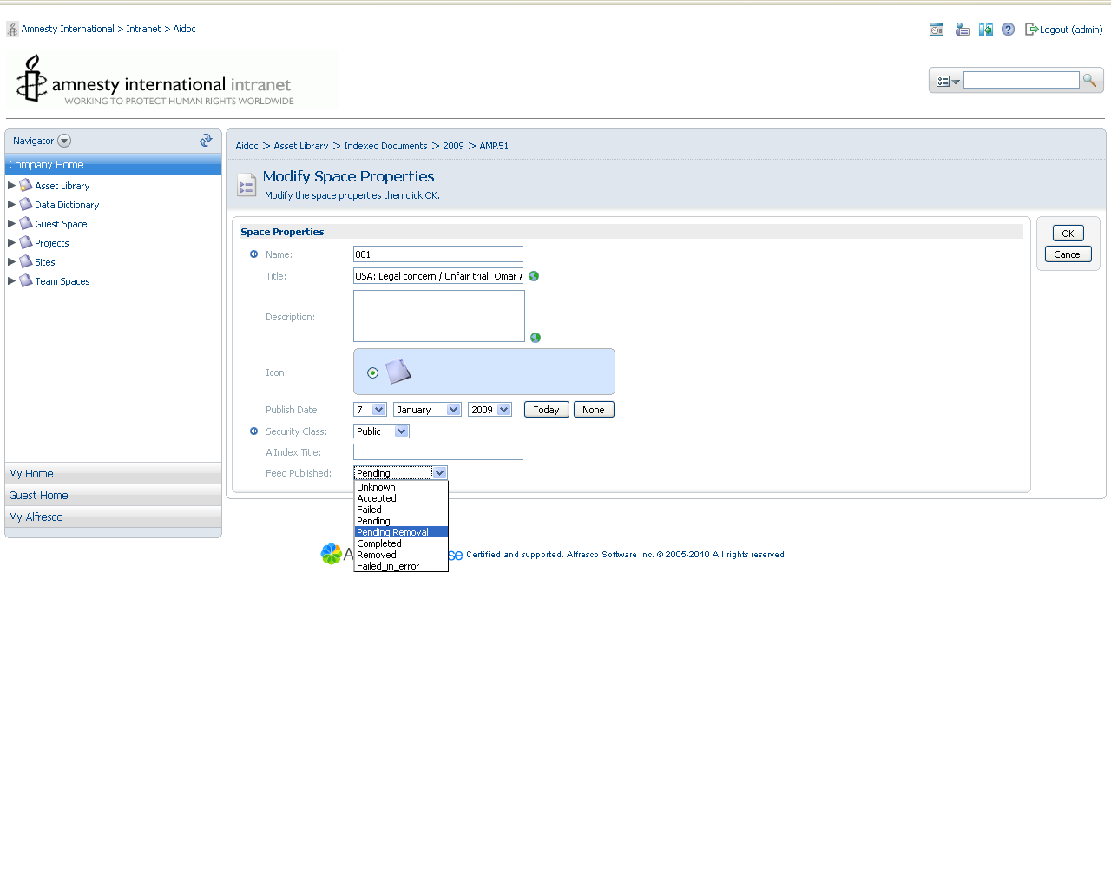

  - Templates
Location | Context File | Description
Src/main/config/bootstrap/  Present-templates | Ai_asset_info.ftl | Define template for HTML part in Custom View section of Asset View Detail page. Displays the Feed Published property.

    - Ai_asset_info.ftl
The Asset Feed Published status is displayed in the Custom View.
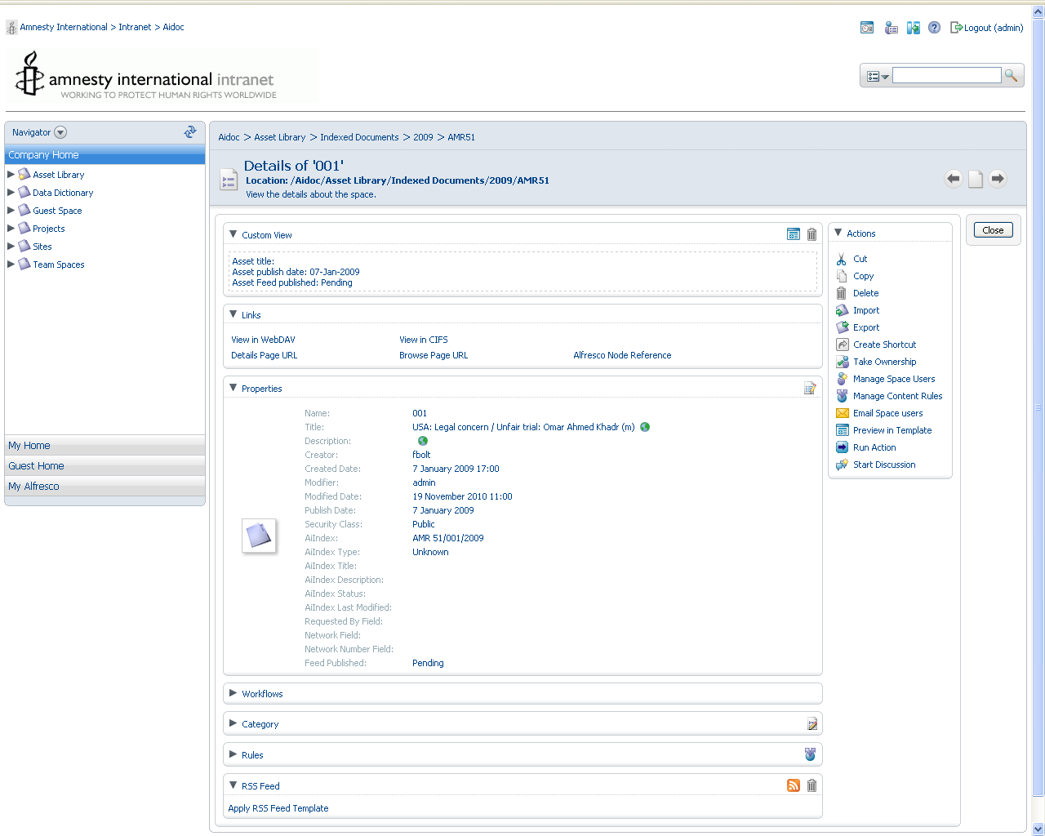

  - Properties Files

Location | Context File | Description
Src/main/resources/ | Aicore.properties | GSA server and Feed properties.

6.5.1 Aicore.properties – what the properties mean:
Property Name | Default value | Description
gsa.server.protocol | https | GSA server and Feed properties.
gsa.server.host | gsa1.amnesty.org | Hostname of GSA  gsa1.amnesty.org – test  gsa2.amnesty.org –live
gsa.server.port | 443 | For Search interface on GSA – used by IntranetSearch application.
gsa.server.path | /search | Used by IntranetSearch application.
gsa.public.collection | ai_unrestricted | GSA collection, Used by IntranetSearch application.
gsa.internal.collection | ai_restricted | GSA collection, Used by IntranetSearch application.
gsa.result_per_page | 10 | Used by IntranetSearch application.
gsa.user | alfresco | Admin User setup in GSA for the IndexingFeederActionExcecuter. Specifically used for the GSA Admin API to verify feeds indexed in GSA.
gsa.password | alfresco | As above.
gsa.feeder.url | http://gsa1.amnesty.org:19900/xmlfeed | GSA Feedergate URL where XML Feeds are submit via HTTP Multipart POST
gsa.feeder.getbacklogcount. url | http://gsa1.amnesty.org:19900/getbacklogcount | GSA Getbacklogcount URL - Obtains integer count of Feeds awaiting processing.
gsa.record.url.prefix | https://192.168.1.137/service/library | Prefix for document rendition URLS to be indexed in GSA.
gsa.feeder.document. datasourcename | ai_alfresco | Collection of feeds in GSA to which the feeds are sent to.
gsa.feeder.document.feedtype | incremental | Determines how GSA handles the feed.” Full” – GSA deletes prior URLS and replaces with new URLS. “incremental” – modified existing URLS in content datasource according to action parameter (either and add or delete feed).
gsa.feeder.document.lock | false | Documents with Lock=true are deleted last when GSA reaches its licence limits.
gsa.feeder.delay.seconds | 1 | Delay in seconds between each HTTP POST of XML bulk feeds to GSA. Prevents to high load of XML feeds being sent in a short space of time to GSA. Negative value prevents HTTP POST and just only lists document renditions.
report.folder | /home/alfresco/sybase_xml/source | Location of Reporting files placed for Sybase. Used by Reporting application.

For more info please refer to:
http://code.google.com/apis/searchappliance/documentation/62/feedsguide.html

  - Library Dependencies
The following GSA Admin API libraries are required in the Maven repository prior to building the application from source.
Add the following depencies to the amp-aicore project’s pom.xml file:
<dependency>
<groupId>com.google.gdata</groupId>
<artifactId>gdata-client</artifactId>
<version>1.0</version>
</dependency>
<dependency>
<groupId>com.google.gdata</groupId>
<artifactId>gdata-client-meta</artifactId>
<version>1.0</version>
</dependency>
<dependency>
<groupId>com.google.gdata</groupId>
<artifactId>gdata-core</artifactId>
<version>1.0</version>
</dependency>
<dependency>
<groupId>com.google.gdata</groupId>
<artifactId>gdata-gsa</artifactId>
<version>1.0</version>
</dependency>
<dependency>
<groupId>com.google.gdata</groupId>
<artifactId>gdata-gsa-meta</artifactId>
<version>1.0</version>
</dependency>

- Operations Manual
This section describes how to use the feeds functionality assuming it is enabled in the bootstrap-content.xml.
Note: Please ensure the setting in aicore.properties match the environment that the application is going to be deployed to.
An admin has been create using the GSA Admin console. This user is defined in aicore.properties and set as:
Username: alfresco
Password: alfresco.
Initially Asset node’s View Details page will not display the Feed Published property as this is not a mandatory field as defined in the Aicore model.

The Asset Feed Publish property in the Custom View will remain empty until a feed is generated and sent out for the first time.
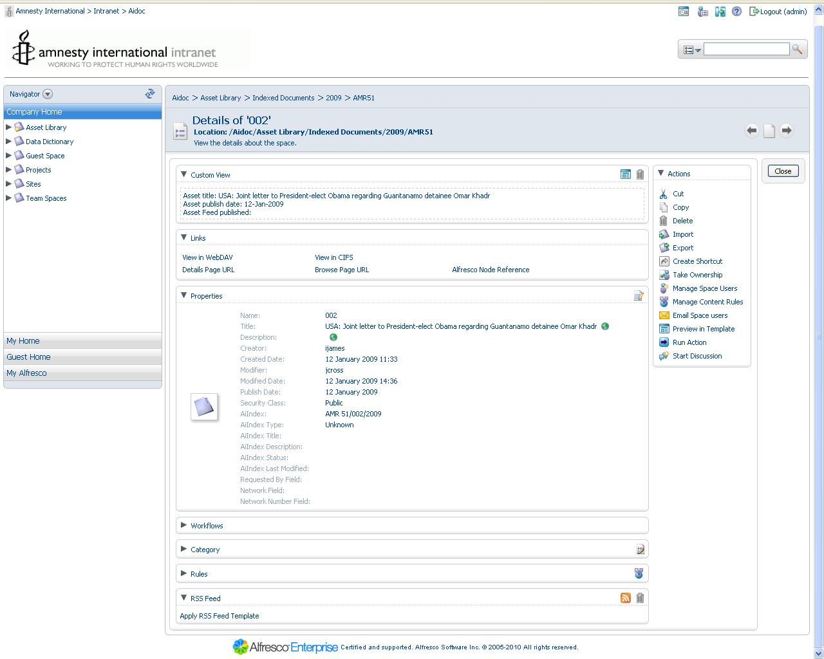

The following user scenario changes to the Aidoc repository will trigger the Feeds actions:
- Adding new documents.
- Modifiying documents or document node properties.
- Deleting documents.
- Modifying the Asset node’s security class.

Following is a walk-through of each of the scenarios:

  - Adding new documents

1) Add a document in Alfresco:
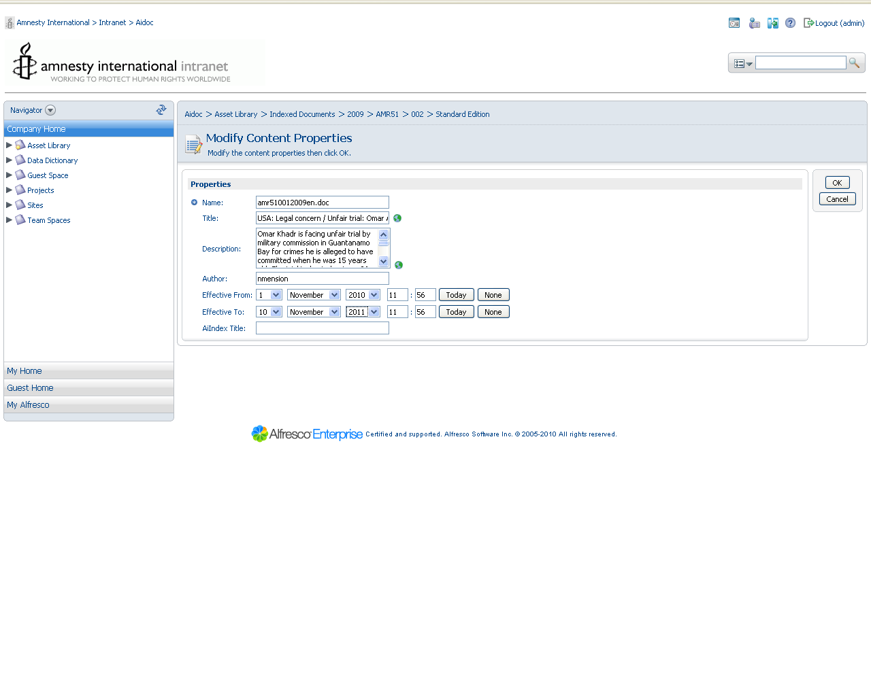
2) View Details of the Asset Node for the document added. Feed Published is set to “Pending” State. This means a indexing feed has been sent to the GSA and a HTTP 200 response and the getBacklogfeedCount has been incremented.
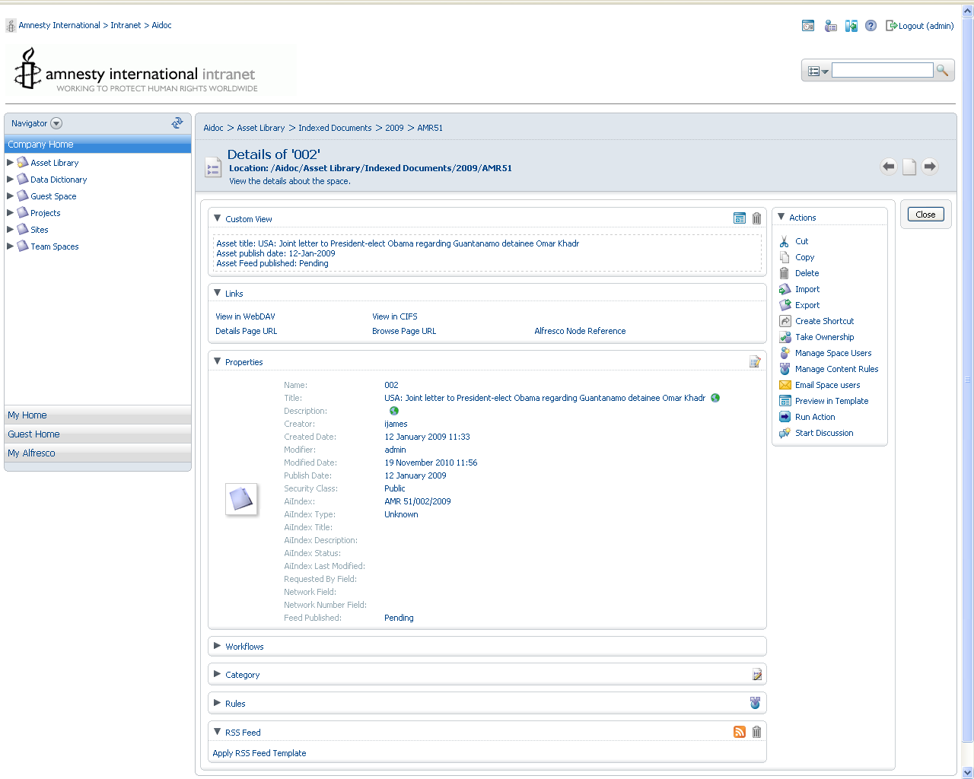
3) Login into the GSA Admin Console and examine the Current Feeds to verify your document feed has been sent and “In progress”. Normally after 6mins this changes to Completed when it is in the queue to be processed by GSA Feeder to index the document.
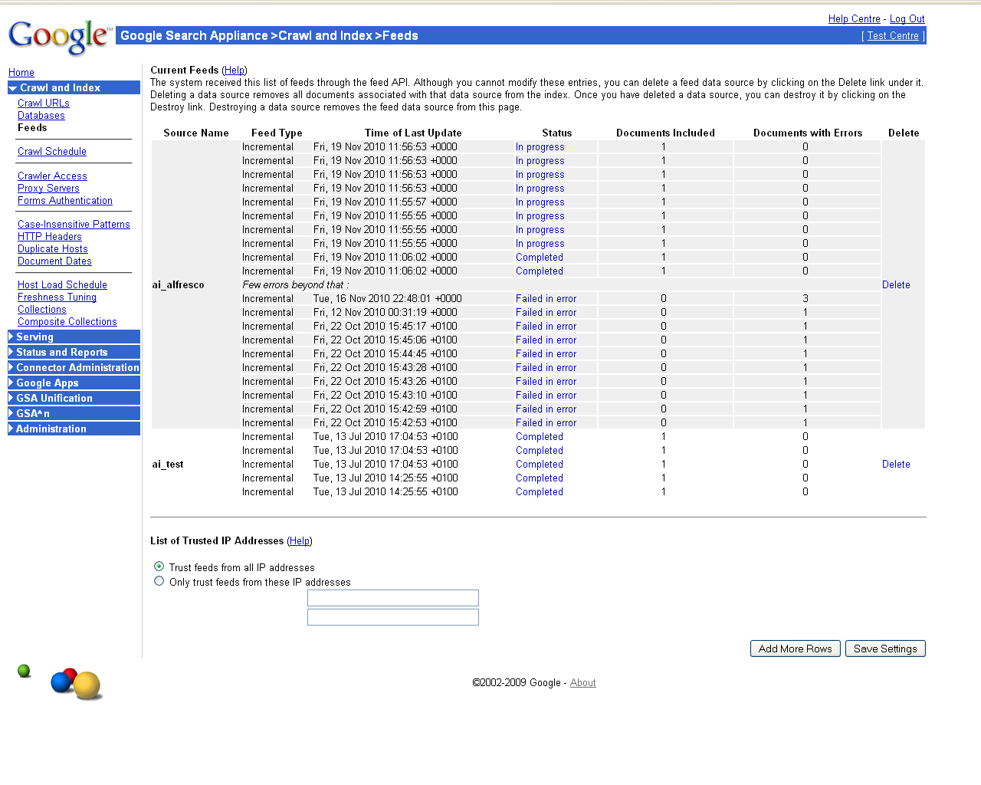
4) After some time usually within 30mins depending on how busy the GSA is, you can check the feed has been indexed in the Crawl Diagnostics page of the GSA Admin console. Your feed has now been successfully indexed.
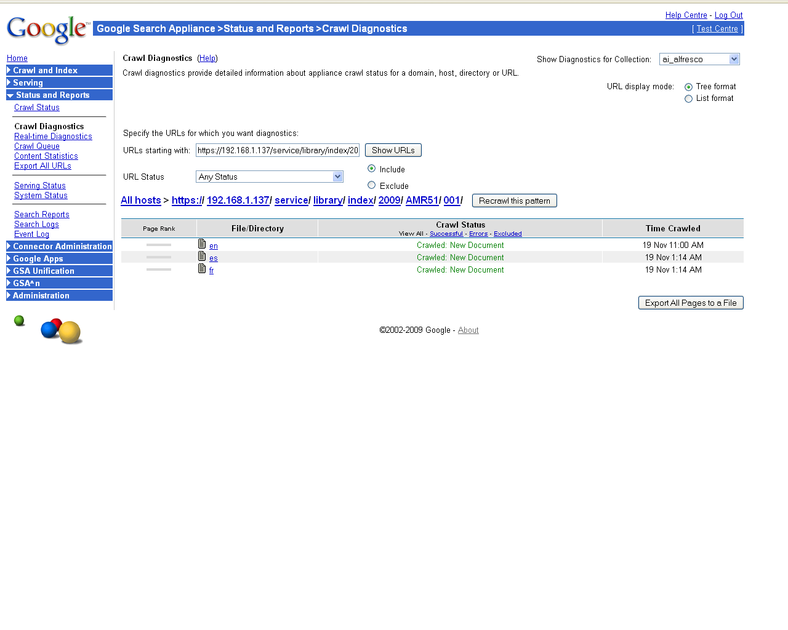
5) However the Feed Published property of the Asset node will show as Pending. The second stage is for the IndexingFeedActionExecutor process to run on a scheduler when Alfresco server is not busy.

For the purpose of this walk through, this Action can be invoked manually. To do this goto the View Details page of the Asset’s node, as in (Step 2).

Click on Run Action and select the following and click finish to execute the Action. This will iterate over all the Aidoc assets and find where Feed Publish is in “Pending” or “Failed” or “Failed_in_error” states. This process will take approximately 5mins to complete hence it is recommended to run this as a scheduled job overnight.

For each of the Feed Published states the Action will take perform the operation as stated in 5.3 Verify Feed Action.
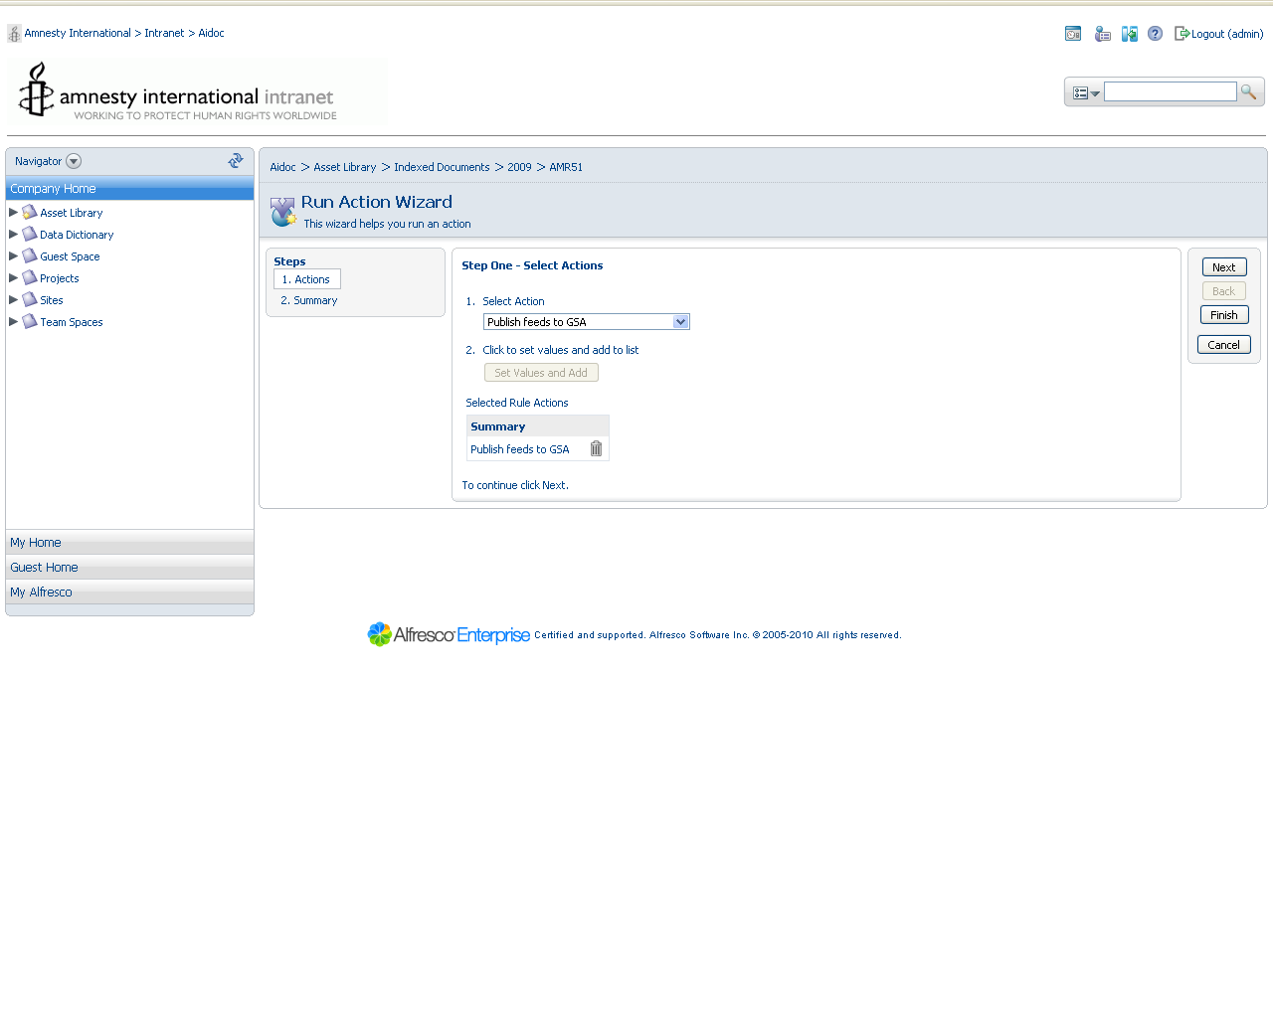
6) On the View Details page of the Asset’s node you should see the Feed Published state set to “Completed” if index was found in GSA. “Failed_in_error” state will occur if the document is not in the GSA Index or not update, greater or equal to the last modified date.

  - Modifiying documents or document node properties
  - Deleting documents
  - Modifying the Asset node’s security class

- Appendix
  - Google Search Appliance Feed DTD
The gsafeed.dtd file follows. You can view the DTD on your search appliance by browsing to the http://<APPLIANCE-HOSTNAME>:7800/gsafeed.dtd URL.
<?xml version="1.0" encoding="UTF-8"?>
<!ELEMENT gsafeed (header, group+)>
<!ELEMENT header (datasource, feedtype)>
<!-- datasource name should match the regex [a-zA-Z_][a-zA-Z0-9_-]*,
the first character must be a letter or underscore,
the rest of the characters can be alphanumeric, dash, or underscore. -->
<!ELEMENT datasource (#PCDATA)>
<!-- feedtype must be either 'full', 'incremental', or 'metadata-and-url' -->
<!ELEMENT feedtype (#PCDATA)>

<!-- group element lets you group records together and
specify a common action for them -->
<!ELEMENT group (record*)>

<!-- record element can have attribute that overrides group's element-->
<!ELEMENT record (metadata*,content*)>
<!ELEMENT metadata (meta*)>
<!ELEMENT meta EMPTY>
<!ELEMENT content (#PCDATA)>

<!-- default is 'add' -->
<!-- last-modified date as per RFC822 -->
<!ATTLIST group
action (add|delete) "add"
pagerank CDATA #IMPLIED>
<!ATTLIST record
url CDATA #REQUIRED
displayurl CDATA #IMPLIED
action (add|delete) #IMPLIED
mimetype CDATA #REQUIRED
last-modified CDATA #IMPLIED
lock (true|false) "false"
authmethod (none|httpbasic|ntlm|httpsso) "none"
pagerank CDATA #IMPLIED>

<!ATTLIST meta
encoding (base64binary) #IMPLIED
name CDATA #REQUIRED
content CDATA #REQUIRED>

<!-- for content, if encoding is specified, it should be either base64binary
(base64 encoded) or base64compressed (zlib compressed and then base64
encoded). -->
<!ATTLIST content encoding (base64binary|base64compressed) #IMPLIED>

